The documentation about basic Linux and its commands
1.Introduction to Linux
What is Linux?
Linux is an open-source operating system (OS) that is based on UNIX.
It manages computer hardware, software, files, processes, and users.
Linux distributions (Ubuntu, CentOS, Fedora, Debian, etc.)
Linux architecture (Kernel, Shell, User space)
Login, logout, shutdown, reboot

2. Basic Linux Commands
File and directory commands: 1. ls, 2.pwd, 3.cd, 4.mkdir, 5.rmdir
1.ls
2.pwd
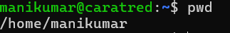
3.cd
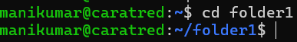
4.mkdir(create directory)
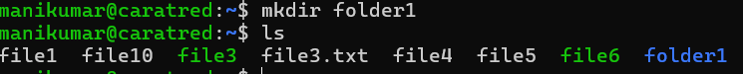
5.rmdir(remove directory)
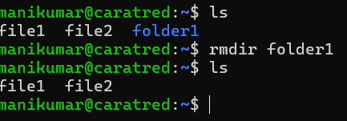

File operations: 1.touch 2. Cat 3.cp 4.mv 5.rm
1.touch
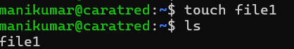
2.cat
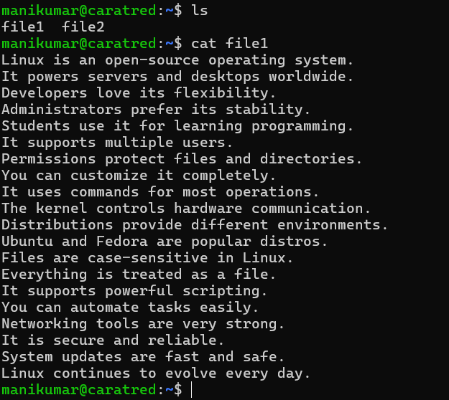
3.cp (copying file1 data to file2)
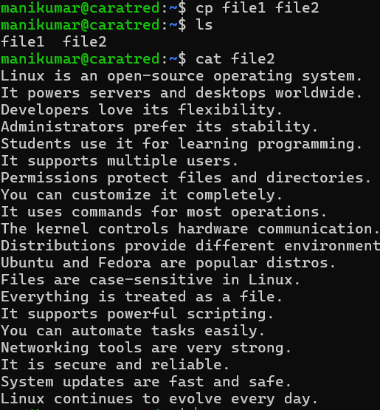
4.mv (moving file1 to file2)
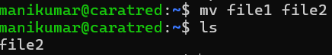
5.rm(remove file)
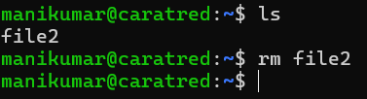

Viewing files: 1.less 2.more 3.head 4.tail 5.nano
1.less
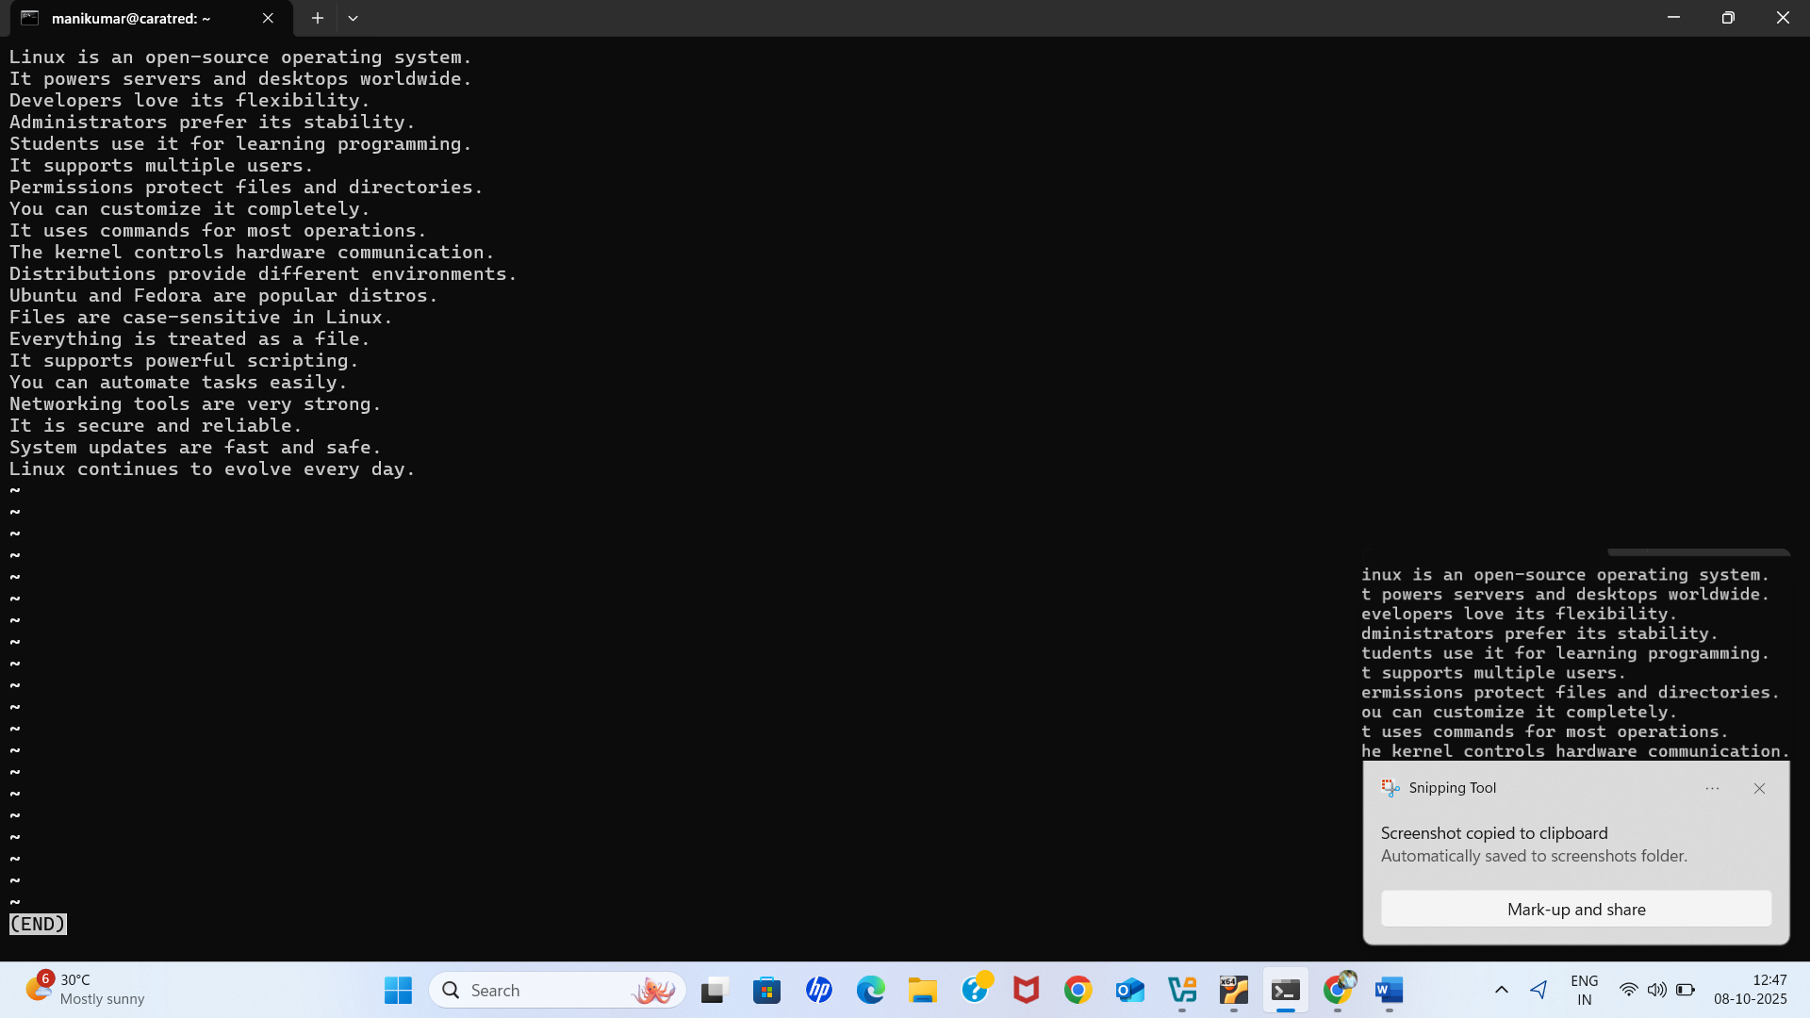
Options we use in less(d , D , / )
d → Scroll half page down
D → Scroll full page down
/ → Search for a pattern (type word and press Enter)

2.more
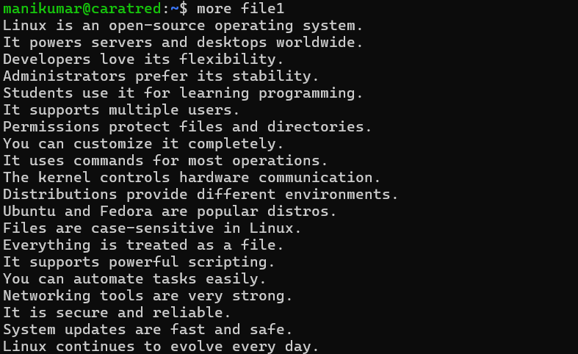
more command: Used to view text files page by page in Linux.
3.head
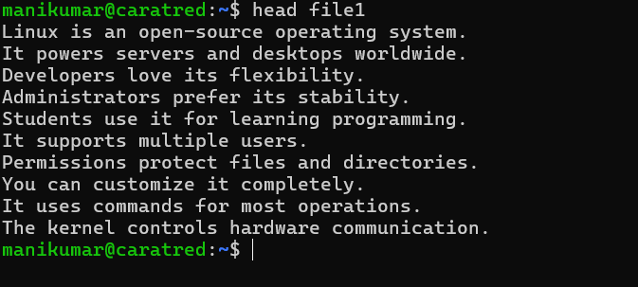
Head means to show first 10 lines
4.tail
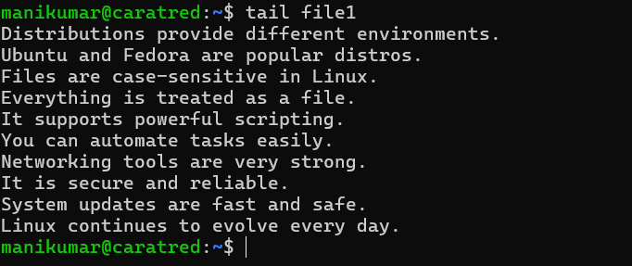
Tail means to show last 10 lines
There is -n option to search line
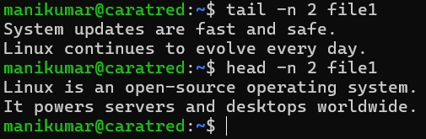

5.nano (To change the content of the files)
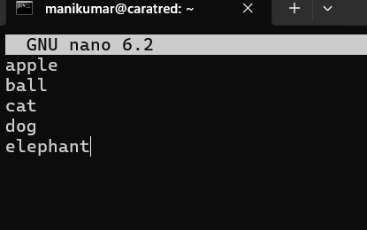
nano command: Used to create or edit text files in a simple terminal-based editor.
Easy text editor in Linux.
1.Ctrl + O → Save file
2.Ctrl + X → Exit
3.Ctrl + K → Cut line
4.Ctrl + U → Paste line

Searching: 1.find 2.locate 3.grep 4.sort
1.find (to find file and folder)
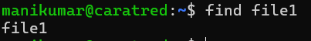
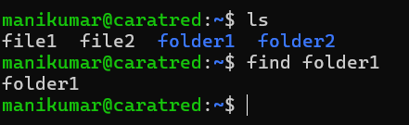
find . -type f -name "*.txt" - to find file/folder
2.locate
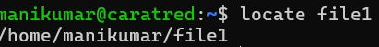
locate command: Used to quickly find files by name
C | - Count number of matches | locate -c *.log → shows how many .log files exist
 | 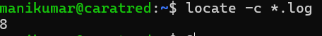
i - Case-insensitive search - locate -i File.TXT → matches file.txt, File.txt
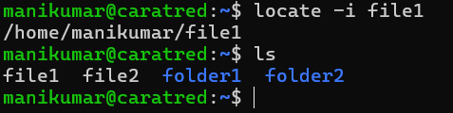

3.grep
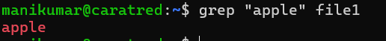
Grep - Search for a pattern (text/word) in files.

4.sort
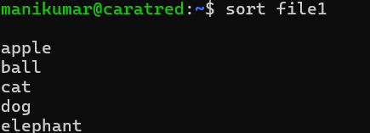
Sort - sort is a Linux command used to arrange of text in a file or output in order.

cd .. -moves one step back (from parent directory).
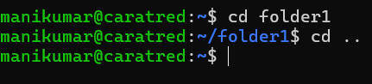

rm -rf * - After a star clean all data
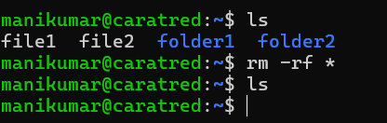

--------------------------------------------------------------------------------------------------------------------------------------
ls -l - to get long list
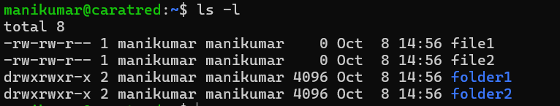
ls -a - to show hidden files
ls -lh - human readable
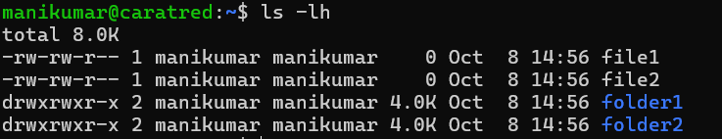
ls -R -- recursive option, lists all files and directories including subdirectories.
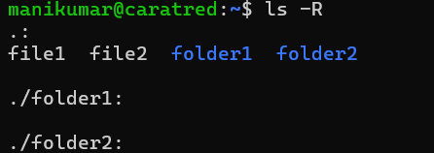
ls -r - reverse direction
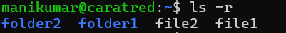
copy
---------------
cp -r - Recurrsive(recursive, copies directories along with all their contents (subdirectories + files).
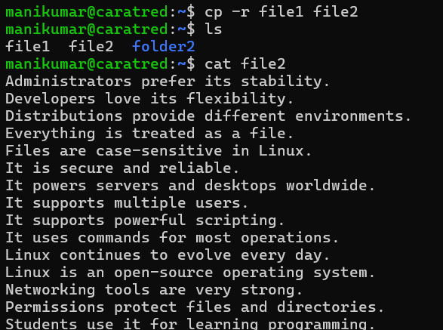

cp -i To ask permission override the file {check if there is option not to override the data}?
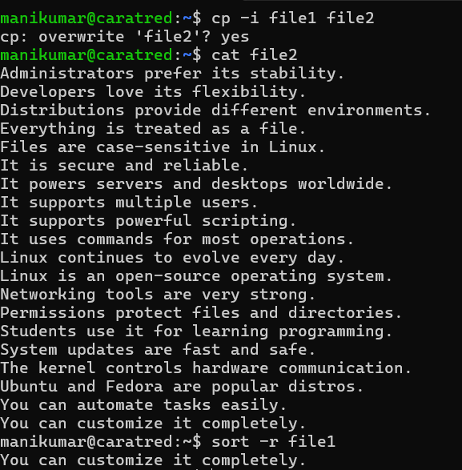
cp- v - copy multiple files in verbos (each file being copied on the terminal)
cp - >> - append the data
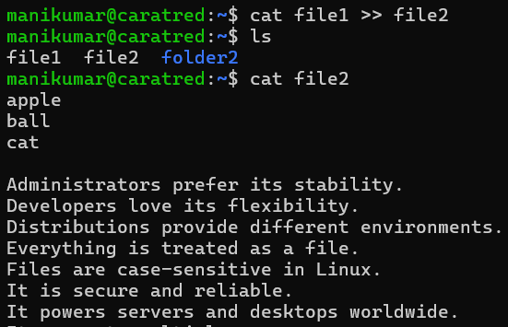
Remove
rm -r - removal (should remove file only)
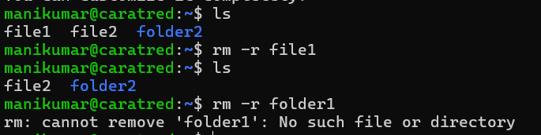
rm -rf - force → no confirmation, even if write-protected
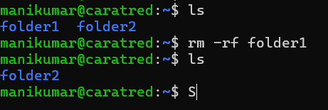

rm -ri - remove files or directories -i interactive mode, prompts “are you sure?” for each file
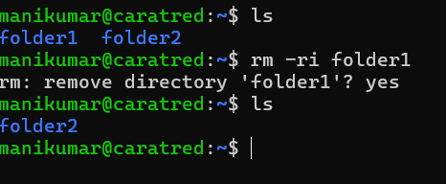
rm -v - verbous remove(It shows what is being removed on the terminal.) like removed 'file2'
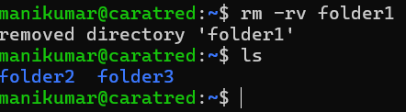z
3. File Permissions & Ownership
File types & permissions (rwx)
1. chmod (Change File Permissions)
Use: To change the read, write, execute permissions of a file or directory.
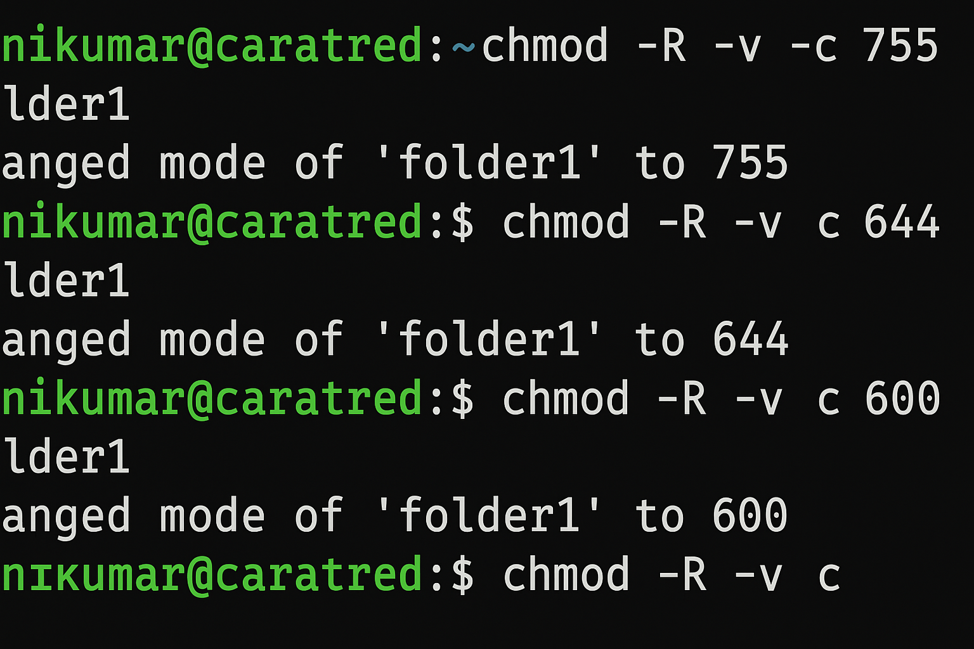

2.chown (Change Owner)
Use: To change the owner (and optionally group) of a file or directory.

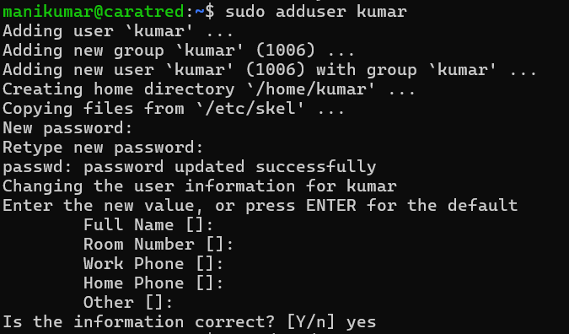
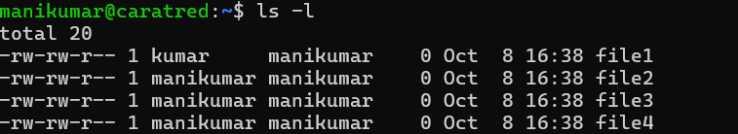

3. chgrp (Change Group Ownership)
Use: To change only the group ownership of a file or directory
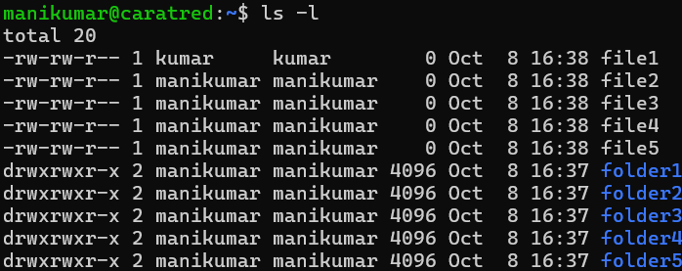

Option | Description
-R | Apply changes recursively to all files/subfolders
-v | Show (verbose) which files were changed
-c | Show changes only when permissions actually change

4. Users & Groups
- Add a User – useradd (Creates a new user account)

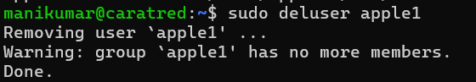

To create user – cat /etc/passwd

- Modify a User – usermod (Changes existing user settings)

Syntax:
sudo usermod -d username

Useful options:
-aG → Add to supplementary username

5. Delete a User – deluser / userdel
Removes a user account.

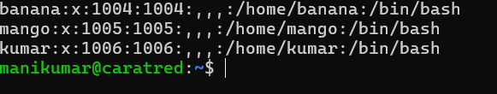
Hear kalyan user account is removed

6.Links (ln)
1. Hard Link
Another reference to the same data.
Even if original file is deleted, hard link still works (until all links are removed).
Syntax:
ln file1 hardlink1

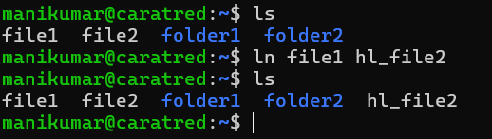
Syntax
---------
- Soft Link (Symbolic Link)

Syntax:
ln -s file1 softlink
7.These are all group creating commands
----------------------
sudo groupadd -g groupname ---> to create a group
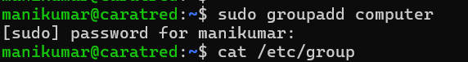
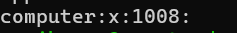
sudo groupmod -n changename original name ---> to change a name

sudo groupmod -d number groupname ---> to change a number
sudo delgroup groupname ---> to delete a group
sudo usermod -aG groupname username --> to modify the user add to secondary group
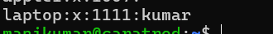
sudo gpasswd -d user groupname --->remove user from group
sudo usermod -aG groupname username ---> groups are added to ids

8.Tar , Hardlink and softlink
tar -cvf filename.tar filename -- to create tar
tar -cvf filename.tar file1 file2 -> two files are added in tar
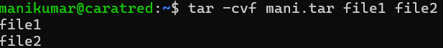
tar – czvf filename.tar.gz file1 file2 - compress two files in filename
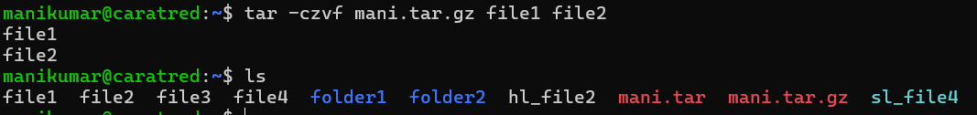
tar -tvf filename.tar.gz -- to verify compressed or not
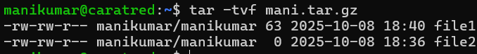

-------------------------------------------------------------------------------------------------------------------------
>> - append the text into file
Echo “mani” >> filename
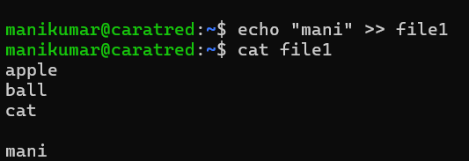

<< - multiple lines saved into files
Cat <<end >
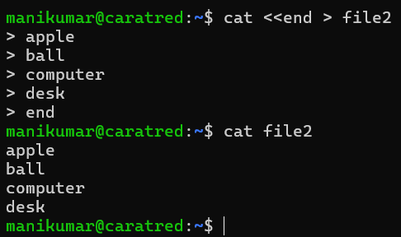

df -h --- anywhere in Linux to check disk space usage — especially when you want to know how much storage is free or full on your system or drives.
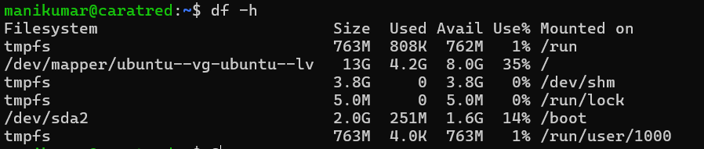

free -h → shows system memory (RAM) usage in human-readable format
Swap : - how to create swap in linux and use of it?
top → shows real-time system performance (CPU, memory, running processes).
